**SWEETY.R-312319106162**

**HOME AUTOMATION**

**TINKERCAD DESIGN:**

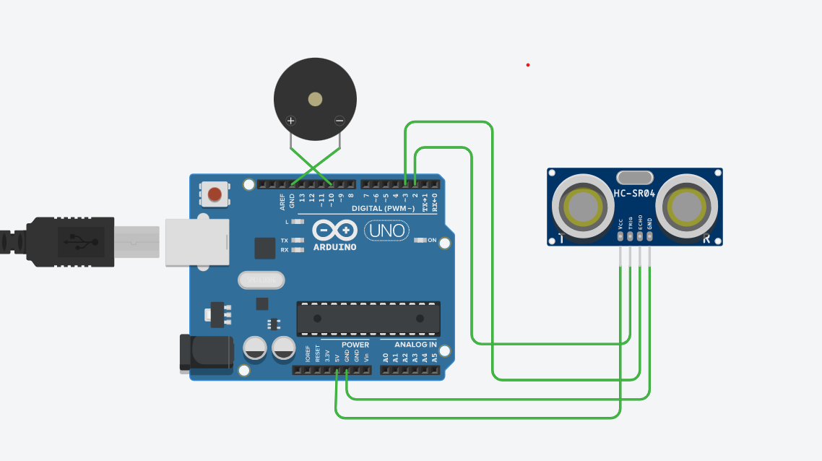

**TINKERCAD LINK:**

[**https://www.tinkercad.com/things/8NYt0VuQbEB-frantic-albar-fulffy/editel?tenant=circuits**](https://www.tinkercad.com/things/8NYt0VuQbEB-frantic-albar-fulffy/editel?tenant=circuits)

**TINKERCAD CODE:**

**int trigger_pin = 2;**

**int echo_pin = 3;**

**int buzzer_pin = 10;**

**int time;**

**int distance;**

**void setup()**

**{**

**Serial.begin (9600);**

**pinMode (trigger_pin, OUTPUT);**

**pinMode (echo_pin, INPUT);**

**pinMode (buzzer_pin, OUTPUT);**

**}**

**void loop()**

**{**

**digitalWrite (trigger_pin, HIGH);**

**delayMicroseconds (10);**

**digitalWrite (trigger_pin, LOW);**

**time = pulseIn (echo_pin, HIGH);**

**distance = (time * 0.034) / 2;**

if (distance <= 10)

{

Serial.println (" Door Open ");

Serial.print (" Distance= ");

Serial.println (distance);

digitalWrite (buzzer_pin, HIGH);

**delay (500);**

**}**

**else {**

**Serial.println (" Door closed ");**

**Serial.print (" Distance= ");**

**Serial.println (distance);**

**digitalWrite (buzzer_pin, LOW);**

**delay (500);**

**}**

**}**